

**EC 1310-** Control System

**ROOT LOCUS PLOT**

**Mini project**

Under guidance of

**Dr. M. V. Swati**

Submitted by

Prashant Jha

1714119

**Root Locus**

In control systems theory, root locus analysis is a graphical method for examining how the roots of a system change with variation of a certain system parameter, commonly a gain within a feedback system. This is a technique used as a stability criterion in the field of classical control theory developed by Walter R. Evans which can determine stability of the system. The root locus plots the poles of the closed loop transfer function in the complex s-plane as a function of a gain parameter

**Root Locus Plot**

This is also known as root locus technique in control system and is used for determining the stability of the given system. Now in order to determine the stability of the system using the root locus technique we find the range of values of K for which the complete performance of the system will be satisfactory and the operation is stable.  
Now there are some results that one should remember in order to plot the root locus. These results are written below:

1. Region where root locus exists : After plotting all the poles and zeros on the plane, we can easily find out the region of existence of the root locus by using one simple rule which is written below,  
   Only that segment will be considered in making root locus if the total number of poles and zeros at the right hand side of the segment is odd.
2. How to calculate the number of separate root loci ? : A number of separate root loci are equal to the total number of roots if number of roots are greater than the number of poles otherwise number of separate root loci is equal to the total number of poles if number of roots are greater than the number of zeros.

RULES FOR CONSTRUCTION OF ROOT LOCUS

Following are the rules to sketch the root locus plot

**RULE 1.** The root locus is symmetrical about the real axis

**RULE 2.** The root locii starts from an open loop pole with K=0

e.g. For the system having

$G\left(s\right)H\left(s\right)=\frac{K\left(s+3\right)}{s+2}$

the starting point of the root loci will be s = -2

**RULE 3.** The root loci will terminate either on an open loop zeros or on infinity with K = ∞

e.g. For the system having

$G\left(s\right)H\left(s\right)=\frac{K\left(s+3\right)}{s+2}$

The root loci will terminate at s = -3

**RULE 4.** If N = No. of separate loci

P = No. of finite poles

Z = No. of finite zeros then

number of root loci will be equal to the no. of poles if number of poles are more than number of zeros i.e. P > Z

N =P if P > Z

If Z > P, then number of root loci will be equal to the number of zeros

If P = Z then No. of root locii = Poles = Zeros

e.g. For the system having

$G\left(s\right)H\left(s\right)=\frac{K\left(s+3\right)}{s+2}$

Since P = 1, Z = 1 therefore N = 1

**RULE 5. ROOT LOCII ON THE REAL AXIS**

Any point on the real axis is a part of the root locus if and only if the number of poles and zeros to its right is odd.

**RULE 6. ASYMPTOTES**

The branches of root locus tend to infinity along a set of straight line called asymptotes. These asymptotes making an angle with real axis and is given by

$ϕ=\frac{\left(2k+1\right){180}^{0}}{P-Z}$ where K = 0,1,2, ……

The total number of asymptotes = P – Z

e.g. If $G\left(s\right)H\left(s\right)=\frac{k}{s\left(s^{2}+6s+10\right)}$

P = 3

Z = 0

No. of asymptotes = P – Z = 3

K = 0 $ϕ_{0}=\frac{\left(2×0+1\right){180}^{0}}{3}={60}^{0}$

K = 1 $ϕ_{1}=\frac{\left(2×1+1\right){180}^{0}}{3}={180}^{0}$

K = 2 $ϕ_{2}=\frac{\left(2×2+1\right){180}^{0}}{3}={300}^{0}$

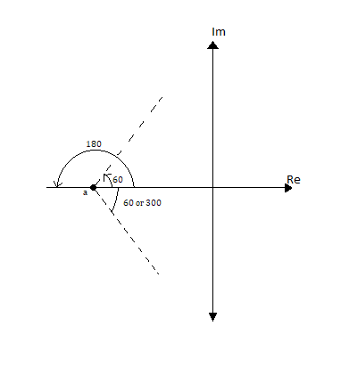

**RULE 7. CENTROID OF ASYMPTOTES**

The point of intersection of asymptotes with real axis is called centroid of asymptotes ($σ_{A}$) and is given by

$σ_{A}=\frac{sum of polⅇs - sum of zⅇros}{P-Z}$

e.g. If $G\left(s\right)H\left(s\right)=\frac{k}{s\left(s^{2}+6s+10\right)}$

There are three poles at $s_{1}=0,s_{2}=-3+j1,S_{3}=-3-j1$

No. of zeros = 0

therefore

centroid $σ_{A}=\frac{0-3+j1-3-j1-0}{3}=-2$

**RULE 8. ANGLE OF DEPARTURE & ANGLE OF ARRIVAL OF THE ROOT LOCII**

The angle of departure of the root locus from a complex pole is given by

- *sum of angles of vectors drawn to this pole from* *other poles + sum of angles of vectors drawn to this pole from zeros*

The angle of arrival at a complex zero is given by

$ϕ_{a}={180}^{0}$*- sum of angles of vectors drawn to this zero from* *other zeros + sum of angles of vectors drawn to this zero from poles.*

e.g. For

$G\left(s\right)H\left(s\right)=\frac{k}{s\left(s+6\right)\left(s^{2}+4s+13\right)}$ 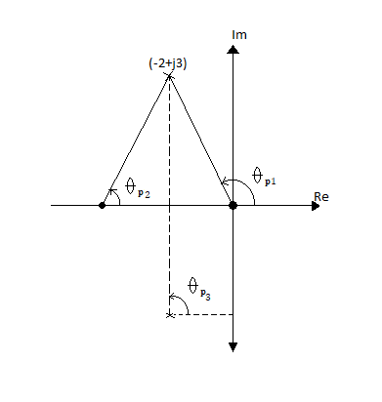

the angle of departure from complex poles.

$$ϕ_{d}=180°-\left(θ_{P_{1}}+θ_{P_{2}}+θ_{P_{3}}\right)=-70°$$

$=180°-\left(123°+37°+90°\right)=-70°$

Therefore, angle of departure at

(-2 + j3) = $70°$

angle of departure at (-2 - j3) = $70°$

**RULE 9. BREAKAWAY POINT ON REAL AXIS**

If the root locus lies between two adjacent open loop poles on the real axis then there will be at least one breakaway point, because the roots move towards each other as K is increased and meet at a point. At this point K is maximum. If we increase the value of K between two poles the root locus breaks in two parts.

Similarly, if root locus lies between two adjacent zeros on real axis then there will be at least one break in point. If the root locus lies between an open loop pole and zero, then there will be no breakaway point or breaking point or may be both occur.

The breakaway or break in points can be determined from the roots of $\frac{ⅆK}{ⅆs}=0$

e.g. If $G\left(s\right)H\left(s\right)=\frac{k}{s\left(s^{2}+6s+10\right)}$

then breakaway point can be calculated as

$1+G\left(s\right)H\left(s\right)=1+\frac{k}{s\left(s^{2}+6s+10\right)}$

$s\left(s^{2}+6s+10\right)+k=0$

or, $K=-s^{3}-6s^{2}-10s$

$\frac{ⅆK}{ⅆs}=-3s^{2}-12s-10=0$

or, $3s^{2}+12s+10=0$

$s_{1}=-1.1835 \& s_{2}=-2.815$ are the breakaway points

**RULE 10.** The intersection of root locus branches with $jω$-axis can be determined through Routh-Hurwitz criterion

e.g. If $G\left(s\right)H\left(s\right)=\frac{k}{s\left(s^{2}+6s+10\right)}$ so, intersection of the root locii with the imaginary axis can be found as

The characteristic equation is $s^{3}+6s^{2}+10s+K=0$

$s^{3}$ 1 10

$s^{2}$ 6 K

$s^{1}$ $\frac{60-K}{6}$

$s^{0}$ K

Hence, we get a zero row if K = 60

The auxiliary equation $A\left(s\right){=6s}^{2}+K$

${6s}^{2}+K=0$

${6s}^{2}+60=0$

Therefore, $s=±j3.16$

The root locus branches cross the imaginary axis at $s=±j3.16$ for K = 60

DETERMINATION OF K ON ROOT LOCII

The value of K can be determined by

$K=\frac{Product of all vector lengths drawn from the poles of G\left(s\right)H\left(s\right) to the point }{Product of all vector lengths drawn from the zeros of G\left(s\right)H\left(s\right) to the point}$

e.g. in the figure

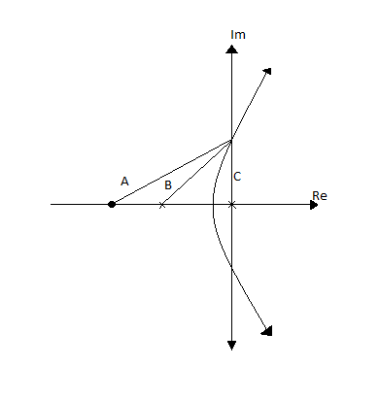

the value of K at the point of intersection of root locus branch with imaginary axis is

$K=\frac{B.C}{A}$

PART B

**For a unity feedback system the open loop transfer function is given by**

$G\left(s\right)=\frac{k}{s\left(s+2\right)\left(s^{2}+6s+25\right)}$

**(a) Sketch the root locus for 0 ≤ K ≤ ∞**

**(b) At what value of ‘K’ the system becomes unstable**

**(c) At this point of instability determine the frequency of oscillation of the system**